 

Welcome

To

Davis-Monthan AFB

Tucson, Arizona

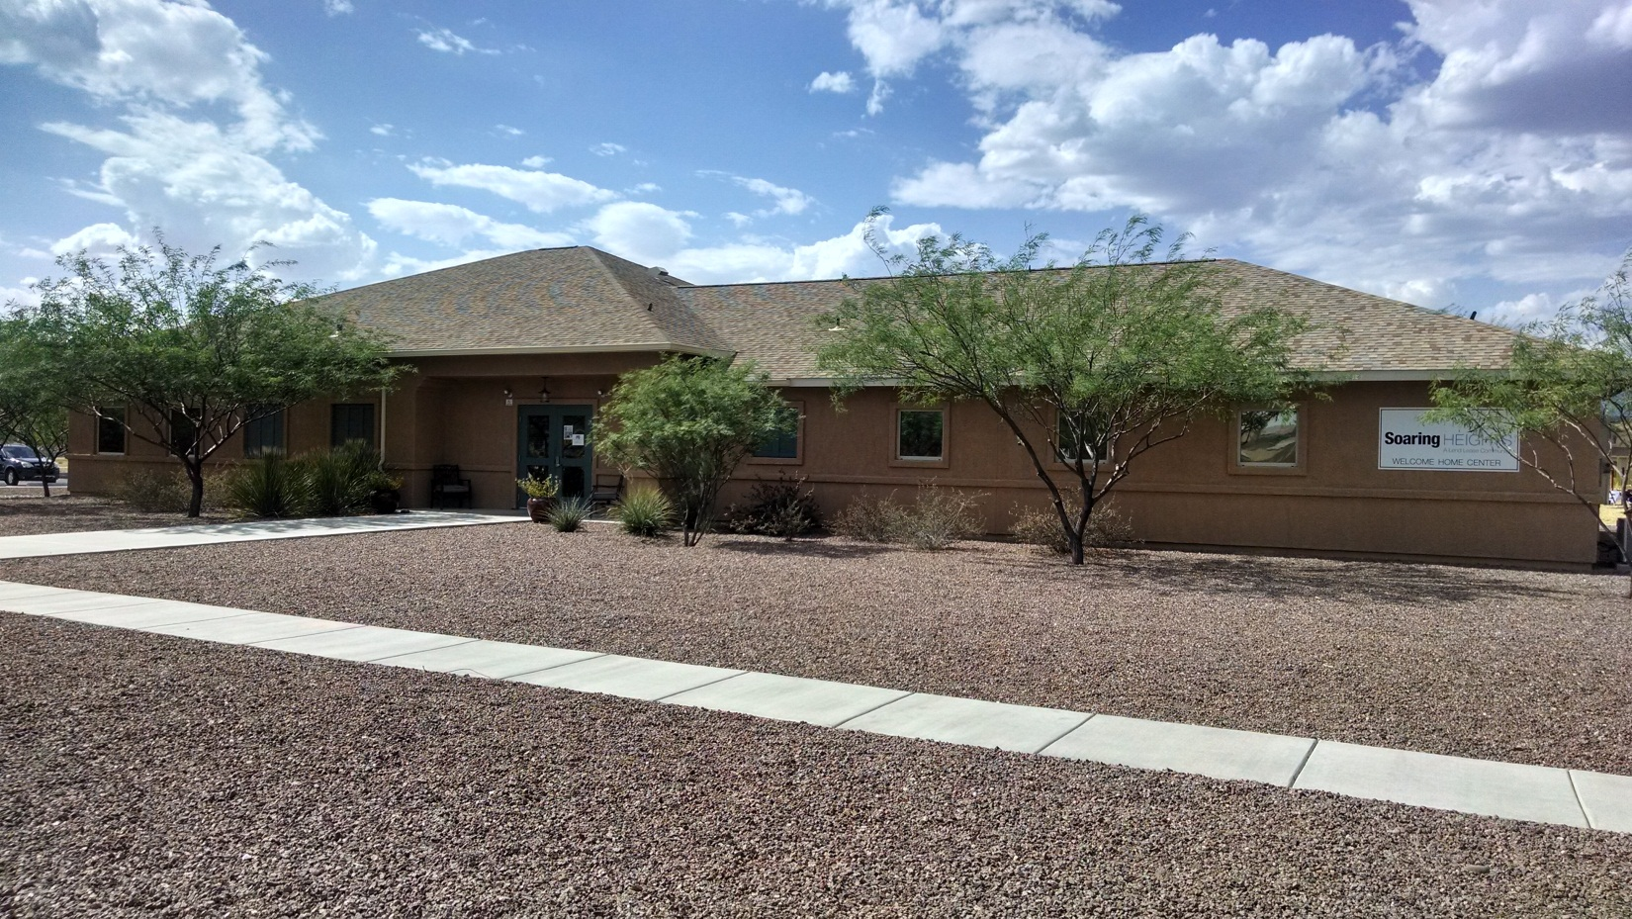

HOUSING REFERRAL & RELOCATION SERVICES

www.housing.af.mil



***Military Housing Management Office (MHO) at Davis-Monthan AFB***

*Welcome to Davis-Monthan AFB and Tucson, Arizona!*

*Please call or stop by our office for the following services:*

* *Referral for privatized military family housing on base, managed by Soaring Heights Communities (*[*http://www.soaringheights.net/*](http://www.soaringheights.net/)*)*
* *Advance housing application to your next base*
* *Lease review/Counseling and guidance before entering into any written lease or rental contract; Sample of Lease Agreement*
* *Short-term lodging information; furnished homes/corporate apartments*
* *Apartment Guide, Rental magazines and Apartment brochures*
* *Copy of Arizona Landlord and Tenant Act*
* *Problem resolution with Property Managers*
* *Bus routes/schedules*
* *Base map*

*If you have any further questions, please visit the Housing Management Office (HMO) on base at*

***8090 East Ironwood Street*** *or call: (****520) 228-3687 / 5705 (DSN: 228)****. For privatized housing, please contact* ***Soaring Heights Communities at (520) 745-5024.***

***~ The Housing Management Office ~***

[*http://www.housing.af.mil/davis-monthan/*](http://www.housing.af.mil/davis-monthan/)

***E-mail:***[*355CES.HMO@us.af.mil*](mailto:355CES.HMO@us.af.mil)

***Hours:*** *Mon, Tue, Wed, Fri: 0700-1700*

*Thu: 0900-1700 (Closed for training: 0700-0900)*

**HELPFUL WEBSITES (As of 1 January 2025):**

[**http://www.housing.af.mil/home/**](http://www.housing.af.mil/home/)  - This is an Air Force public website that provides a venue for members to obtain specific installation information on family, unaccompanied and privatized housing.  Please visit this site for contact details for AF housing offices.​

[**http://www.homes.mil**](http://www.homes.mil) **–** DoD website for home rentals.

[**https://militaryforsalebyowner.net/**](https://militaryforsalebyowner.net/)– Commercial website for rentals and homes for sale.

[**http://www.ahrn.com**](http://www.ahrn.com) – Commercial website with home and apartment rentals.

[**https://www.tucsonrealtors.org/**](https://www.tucsonrealtors.org/)- Tucson Association of Realtors website will let you search for properties (land/lot; rentals; house for sale), open house search, realtor search, view Tucson area map, and give you links to local resources (local govt, school districts, and real estate).

[**http://www.newhomesource.com/**](http://www.newhomesource.com/) - Search for new homes and communities in the local area, and information on new home promotions, model homes, and quick move-in homes.

[**http://www.apartmentratings.com/AZ/Tucson**](http://www.apartmentratings.com/AZ/Tucson) - To find apartment ratings and reviews --- what residents say before you sign a lease. Note: Information here is not verified by MHO.

[**https://www.tucsonaz.gov/Departments/Police**](https://www.tucsonaz.gov/Departments/Police) - Tucson Police Department’s website where you can find crime reports, view maps and crime statistics, etc.

[**https://www.city-data.com/so/so-Tucson-Arizona.html**](https://www.city-data.com/so/so-Tucson-Arizona.html)- updated daily and contains the most recent 6-months of crime and sex offender information / locations.

[**http://www.greatschools.org/**](http://www.greatschools.org/) & [**https://azsbe.az.gov/f-school-letter-grades**](https://azsbe.az.gov/f-school-letter-grades)- to explore top-rated schools and local school information.

[**http://va.gov/**](http://va.gov/) - US Dept of Veterans Affairs provides benefits and services that provide financial and other forms of assistance, like home loans, to Service members, Veterans, their dependents and survivors.

[**http://www.visittucson.org/**](http://www.visittucson.org/) - Visit Tucson website will give you list of things to do in Tucson, events, hotels and resorts, dining, and special offers.

[**http://www.library.pima.gov/**](http://www.library.pima.gov/) - Pima County public library website that shows clickable icons to view locations, hours of operations, events and more.

[**https://azdot.gov**/](https://azdot.gov/) - Arizona Department of Transportation website where you can find MVD offices (locations and business hours), information on Vehicle Registration, Road Conditions, Traffic Cameras, Online Services, and more.

[**http://www.suntran.com/**](http://www.suntran.com/) - An award-winning regional public transportation system, services approximately 20 million passenger trips each year. Whether you're going to work, to an appointment or just to see the sights, Sun Tran can get you there. [**http://www.suntran.com/sunshuttle/**](http://www.suntran.com/sunshuttle/) - Sun Shuttle is a neighborhood transit service in Marana, Oro Valley, Catalina, Sahuarita, Green Valley, San Xavier and Tucson Estates, provided with funding by the Regional Transportation Authority. As part of the regional seamless transit system, Sun Shuttle can take you around your own community, or connect you to Sun Tran services, giving you access to the entire Tucson metropolitan area using public transit.

**DM’s Social Media Sites (provided by Public Affairs):**

[**https://www.facebook.com/DMAFB**](https://www.facebook.com/DMAFB)

[**https://x.com/DMAFB**](https://x.com/DMAFB)

[**https://housing.az.gov/**](https://housing.az.gov/)– Arizona Department of Housing website provides information on housing services to the general public (Apartment rentals, Foreclosure Help-line, Residential Landlord and Tenant Act, Fair Housing Act, Special Needs Assistance, Homeownership Assistance, Emergency Repairs and Housing Rehabilitation, Eviction or Mortgage Foreclosure Assistance, etc).

**ARIZONA RESIDENTIAL LANDLORD AND TENANT ACT - Revised May, 2023**

[**https://housing.az.gov/sites/default/files/documents/files/Landlord_Tenant_Act_May-2023_1.pdf**](https://housing.az.gov/sites/default/files/documents/files/Landlord_Tenant_Act_May-2023_1.pdf)

**Using your Military Clause: What you need to know**

[**https://www.veteransunited.com/futurehomeowners/military-clauses-can-be-a-renters-lifeline-when-duty-calls/**](https://www.veteransunited.com/futurehomeowners/military-clauses-can-be-a-renters-lifeline-when-duty-calls/)